WEEK 12
ROLL N0:241801314
NAME:VIKASHINI.M
Q1
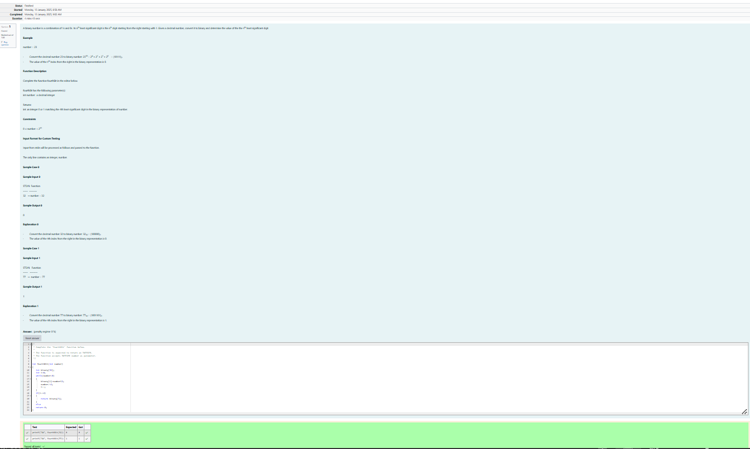
Q2
